|  |  |  |  |
| --- | --- | --- | --- |
| **Name of Student: Pushkar Sane** | | | |
| **Roll Number: 45** | | **Practical Number: 10** | |
| **Title of Lab Assignment: To implement Pandas library in Python.** | | | |
| **DOP:** | | **DOS:** | |
| **CO Mapped:**  **CO6** | **PO Mapped:**  **PO3, PO5, PSO1, PSO2** | **Signature:** | **Marks:** |

**Practical No. 10**

**Aim:** To implement Pandas library in Python.

1. Write a Pandas program to create and display a one dimensional array like object containing an array of data using the pandas module.
2. Write a pandas program to convert a dictionary to a Pandas Series.
3. Write a pandas program to create a dataframe from a dictionary and display it. sample data: {'X': [78,85,96,80,86], 'Y': [84,94,89,83,86], 'Z': [86,97,96,72,83]}
4. Write a pandas program to aggregate the two given data frames along rows and assign all data.
5. Write a pandas program to merge two given dataframes with different columns.

**Description:**

Creating and displaying a one-dimensional array-like object using the Pandas module involves the following key concepts:

1. **Pandas Library:**

Pandas is a powerful open-source data manipulation and analysis library for Python.

It provides data structures and functions for working with structured data, including Series and DataFrame.

1. **Pandas Series:**

A Pandas Series is a one-dimensional labeled array that can hold data of any data type.

It is similar to a NumPy array, but with the added feature of having an index associated with each element.

1. **Creating a Pandas Series:**

To create a Pandas Series, you can use the pd.Series() constructor, which accepts a variety of data types, including lists, dictionaries, and NumPy arrays.

The Series constructor allows you to specify the data and optionally customize the index.

1. **Displaying a Pandas Series:**

You can display the contents of a Pandas Series simply by using the print() function or by calling the Series object directly.

When you display a Pandas Series, you'll see both the data values and the associated index (default is an integer index).

Here's a breakdown of the steps in the Pandas program to create and display a one-dimensional array-like object:

1. Import the Pandas library using import pandas as pd.
2. Create an array of data (e.g., a list) that you want to convert into a Pandas Series.Use the pd.Series() constructor to convert the array of data into a Pandas Series.
3. Optionally, you can customize the index by providing it as an argument when creating the SeriesDisplay the Pandas Series using the print() function or by calling the Series object directly.

Converting a dictionary to a Pandas Series using the pd.Series() constructor is a straightforward process. This allows you to leverage the powerful features of Pandas, such as data analysis, filtering, and manipulation, with your structured data. The resulting Series is a labeled one-dimensional data structure that can be accessed, indexed, and modified to suit your specific data analysis needs.

A Pandas DataFrame can hold data of various types, including integers, floating-point numbers, strings, or more complex objects.

Each column in the DataFrame can have its own data type, depending on the data provided.

In summary, creating a Pandas DataFrame from a dictionary is a powerful way to work with structured data in Python. It allows you to organize and manipulate data in a tabular format, making it easier to perform data analysis, filtering, and other operations on your data. The resulting DataFrame can be used for various data analysis tasks and is a fundamental building block in data science and data engineering.

1. **Write a Pandas program to create and display a one dimensional array like object containing an array of data using the pandas module.**

**Code:**

import pandas as pd

data = [10, 20, 30, 40, 50]

my_series = pd.Series(data)

print(my_series)

**Conclusion:**

Here we have successfully created and displayed a one dimensional array-like object containing an array using pandas.

**Output:**

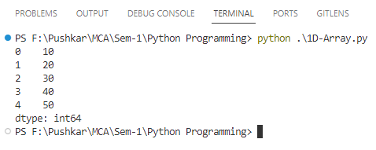

1. **Write a pandas program to convert a dictionary to a Pandas Series.**

**Code:**

import pandas as pd

# Sample dictionary

data_dict = {'A': 10, 'B': 20, 'C': 30, 'D': 40, 'E': 50}

# Convert the dictionary to a Pandas Series

my_series = pd.Series(data_dict)

# Display the Pandas Series

print(my_series)

**Conclusion:**

Here we have successfully converted a dictionary to a Pandas Series.

**Output:**

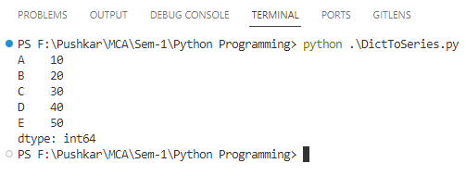

1. **Write a pandas program to create a dataframe from a dictionary and display it. sample data: {'X': [78,85,96,80,86], 'Y': [84,94,89,83,86], 'Z': [86,97,96,72,83]}.**

**Code:**

import pandas as pd

# Sample data dictionary

data_dict = {'X': [78, 85, 96, 80, 86], 'Y': [84, 94, 89, 83, 86], 'Z': [86, 97, 96, 72, 83]}

# Create a Pandas DataFrame from the sample data

df = pd.DataFrame(data_dict)

# Display the DataFrame

print(df)

**Conclusion:**

Here we have successfully a dataframe from a dictionary for the given sample data.

**Output:**

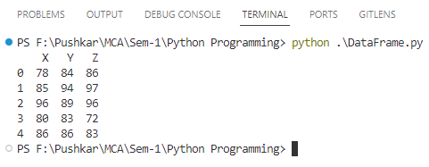

1. **Write a pandas program to aggregate the two given data frames along rows and assign all data.**

**Code:**

import pandas as pd

# Sample data for two DataFrames

data1 = {'A': [1, 2, 3], 'B': [4, 5, 6]}

data2 = {'A': [7, 8, 9], 'B': [10, 11, 12]}

# Create the first DataFrame

df1 = pd.DataFrame(data1)

# Create the second DataFrame

df2 = pd.DataFrame(data2)

# Concatenate the two DataFrames along rows and assign all data

result = pd.concat([df1, df2])

# Display the aggregated DataFrame

print(result)

**Conclusion:**

Here we have successfully aggregated the two given data frames along rows and assigned all data.

**Output:**

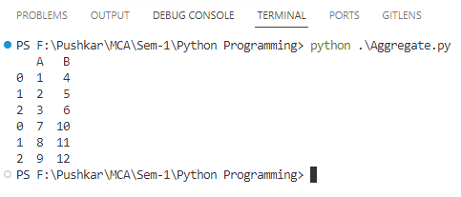

1. **Write a pandas program to merge two given dataframes with different columns.**

**Code:**

import pandas as pd

# Sample data for two DataFrames

data1 = {'ID': [1, 2, 3], 'Name': ['Prasad', 'Anish', 'Shreya']}

data2 = {'ID': [2, 3, 4], 'Age': [25, 30, 35]}

# Create the first DataFrame

df1 = pd.DataFrame(data1)

# Create the second DataFrame

df2 = pd.DataFrame(data2)

# Merge the two DataFrames on the 'ID' column

merged_df = pd.merge(df1, df2, on='ID', how='inner')

# Display the merged DataFrame

print(merged_df)

**Conclusion:**

Here we have successfully merged two given dataframes with different columns.

**Output:**

